**GIT SETUP**

**1) Download and install**

[**https://git-scm.com/downloads**](https://git-scm.com/downloads)

**2) Create folder in drive eg: D:\HackthonApps**

**3) Open git bash**

**I) For Angular type**

**a) cd D:\HackthonApps**

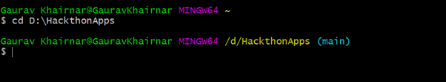

**b) Create clone**

**Execute command:**

**git clone** [**https://github.com/gauravkhrnr21/HackathonDemoApp.git**](https://github.com/gauravkhrnr21/HackathonDemoApp.git)

**II) For Nodejs type**

**a) cd D:\HackathonApps**

**b) create clone**

**Execute command:**

**git clone https://github.com/gauravkhrnr21/HackathonNodeApp.git**

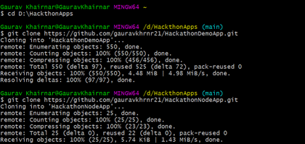

**Download & Install Node**

**1)**  [**https://nodejs.org/en/download/**](https://nodejs.org/en/download/)

**2) Check version**

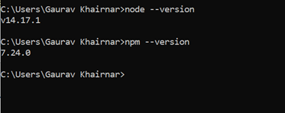

**Install Angular CLI:**

**Npm I @angular/cli**

**https://www.npmjs.com/package/@angular/cli**

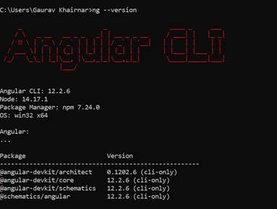

**NodeJS Setup:**

**1) Create new DB (hackathondb) & changes DB credential in db.config.js**

**2) Insert records in roles table**

**INSERT INTO roles VALUES (1, 'user', now(), now());**

**INSERT INTO roles VALUES (2, 'moderator', now(), now());**

**INSERT INTO roles VALUES (3, 'admin', now(), now());**

**3) Check records properly inserted or not**

**Select * from roles;**

**4) Add chrome postman plugin if it’s not there** [**https://chrome.google.com/webstore/detail/postman/fhbjgbiflinjbdggehcddcbncdddomop?hl=en**](https://chrome.google.com/webstore/detail/postman/fhbjgbiflinjbdggehcddcbncdddomop?hl=en)

**5) Got to postman (skip step 4 if plugin already added)**

**6) Add api URI & change request type as post**

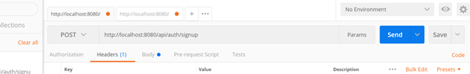

**7) Add content type key in headers as follows**

**key: content-type , value: applicaion/json**

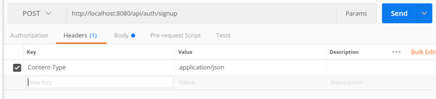

**8) In request body add**

**{**

**"username":"gaurav",**

**"email":"gauravkh@gmail.com",**

**"password":"12345",**

**"roles":["admin"]**

**}**

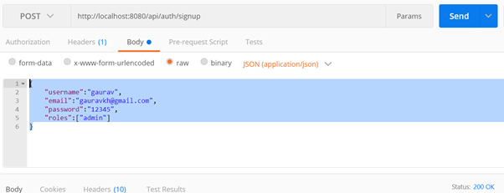

**9) Click on send button and check response body**

**10) RUN**

**1) Go to the angular project root directory & open cmd**

**2) In cmd run “npm install” command**

**3) run “node server.js”**

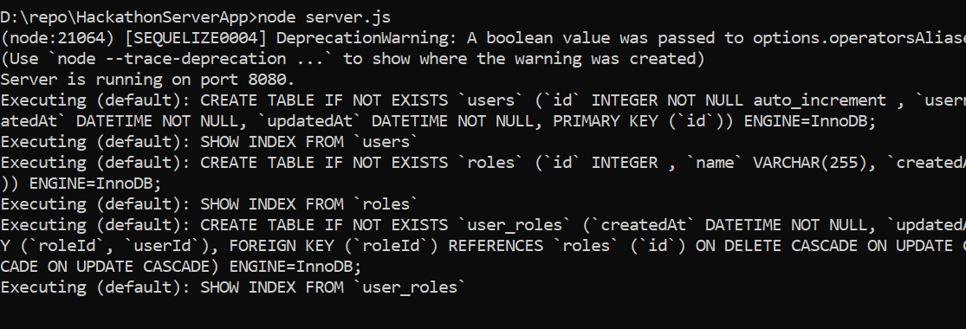

**11) Create model** : go to the project root dir and run below command then it will create model folder

sequelize -auto -h localhost -d (databasename) -u (username) -x (password) --dialect mysql -t (db names)

E.g sequelize -auto -h localhost -d hackathondb -u root -x root --dialect mysql -t users roles

**Angular Setup:**

**1) RUN**

**I) Go to the angular project root directory & open cmd**

**II) In cmd run “npm install -d” command**

**III) run “npm start”**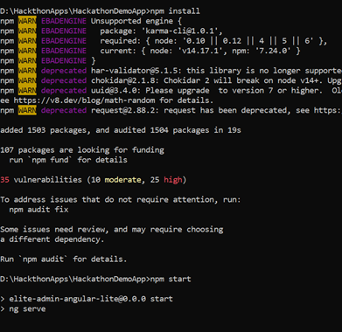

**After login you will see token is stored in session storage:**

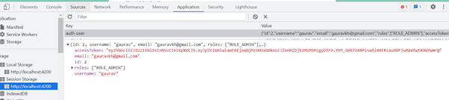

**Screen Shots:**

1. Login Page

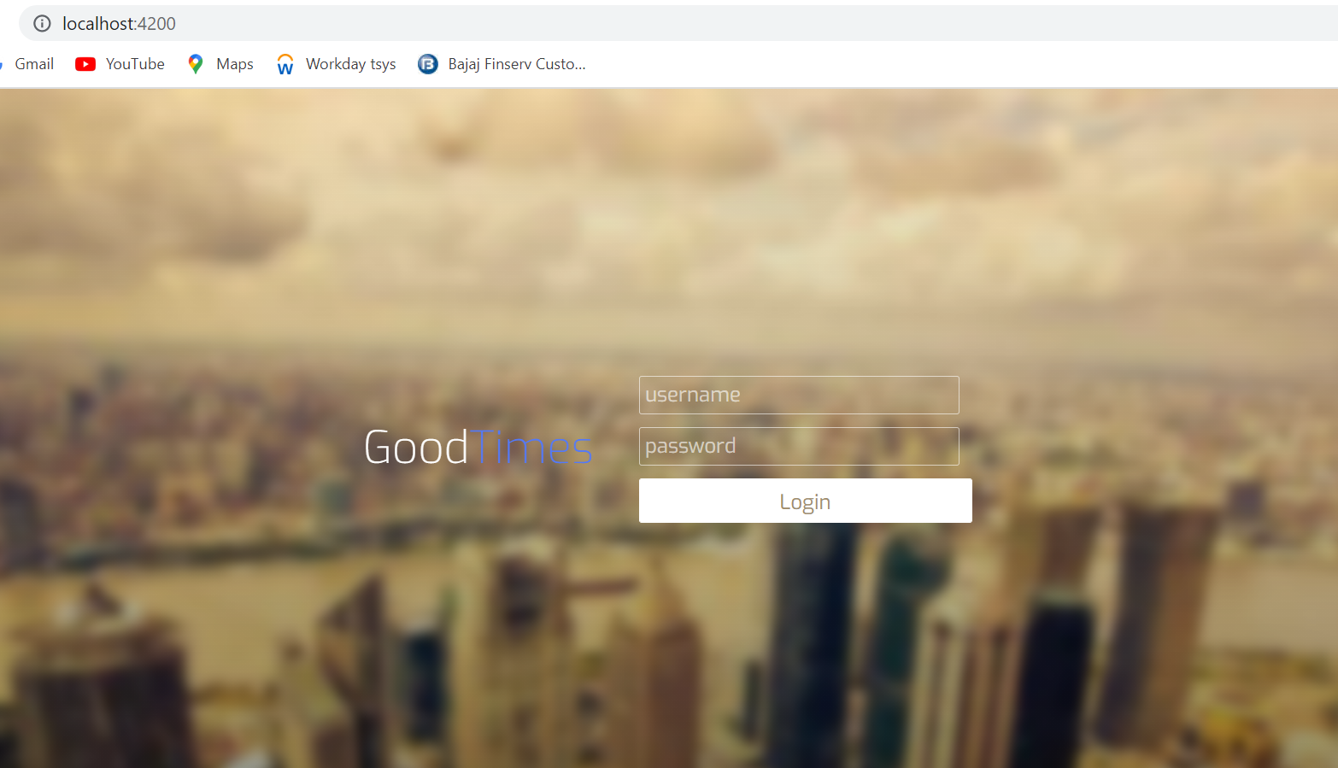

1. Interest Submit Page

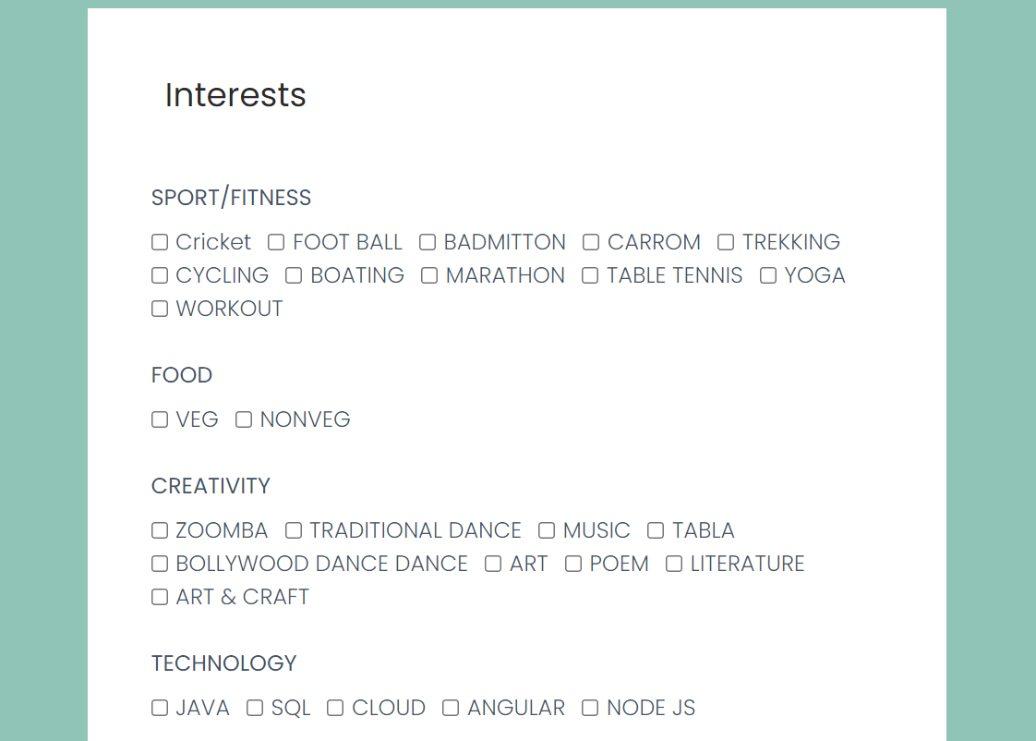

1. Home page

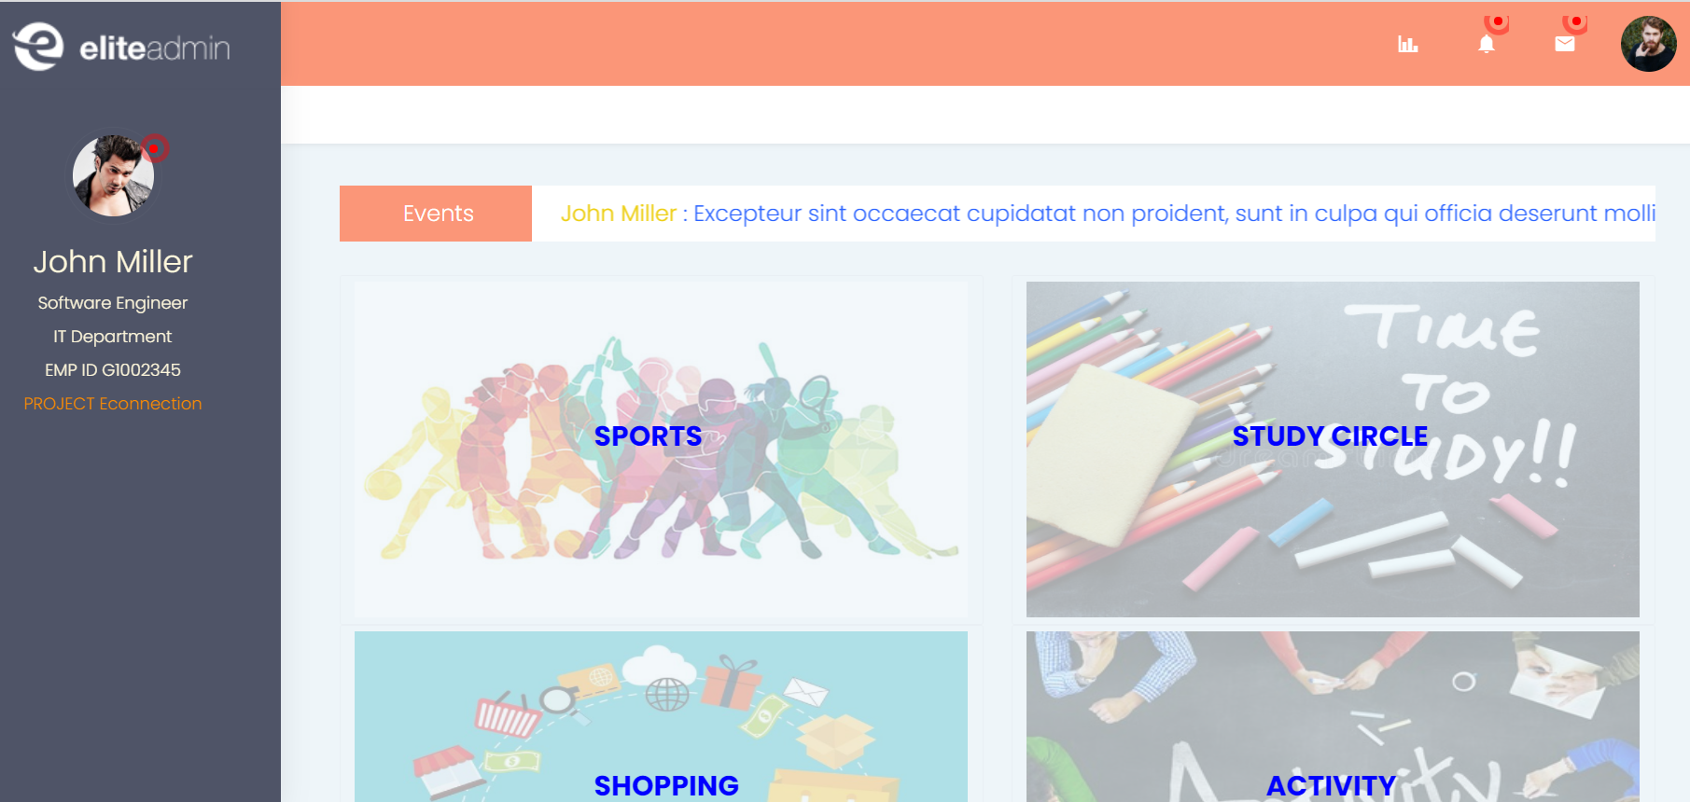

1. Dashboard

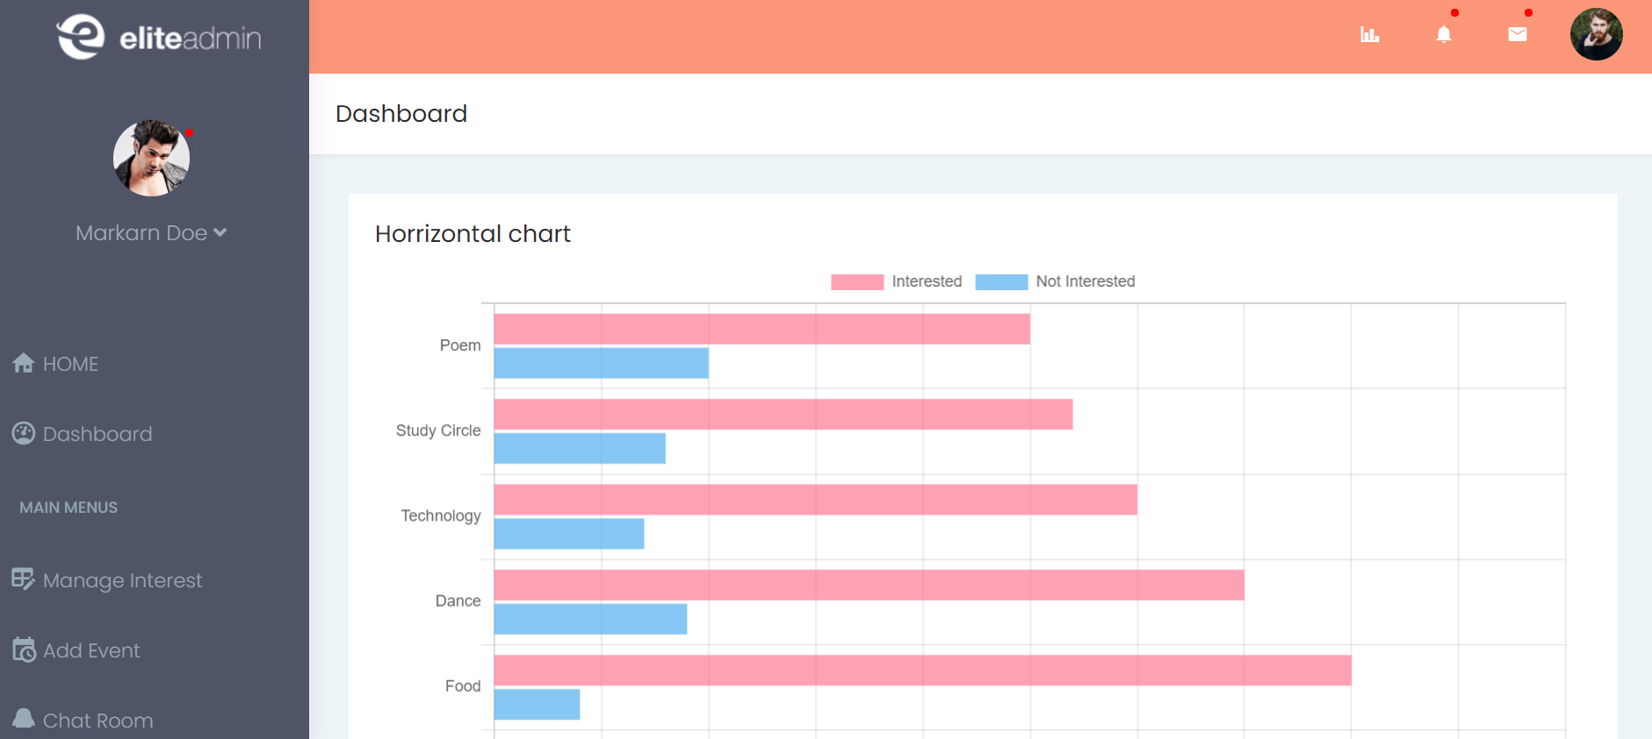

1. Edit Interest

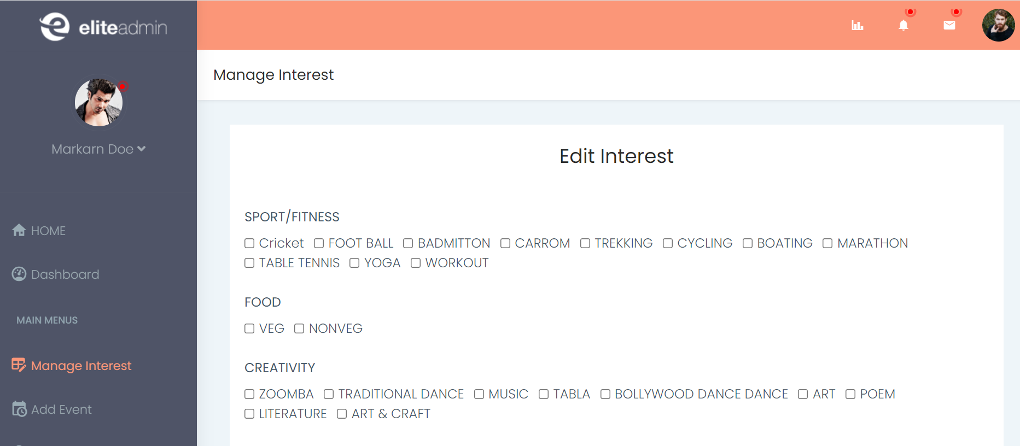

1. Search Interest

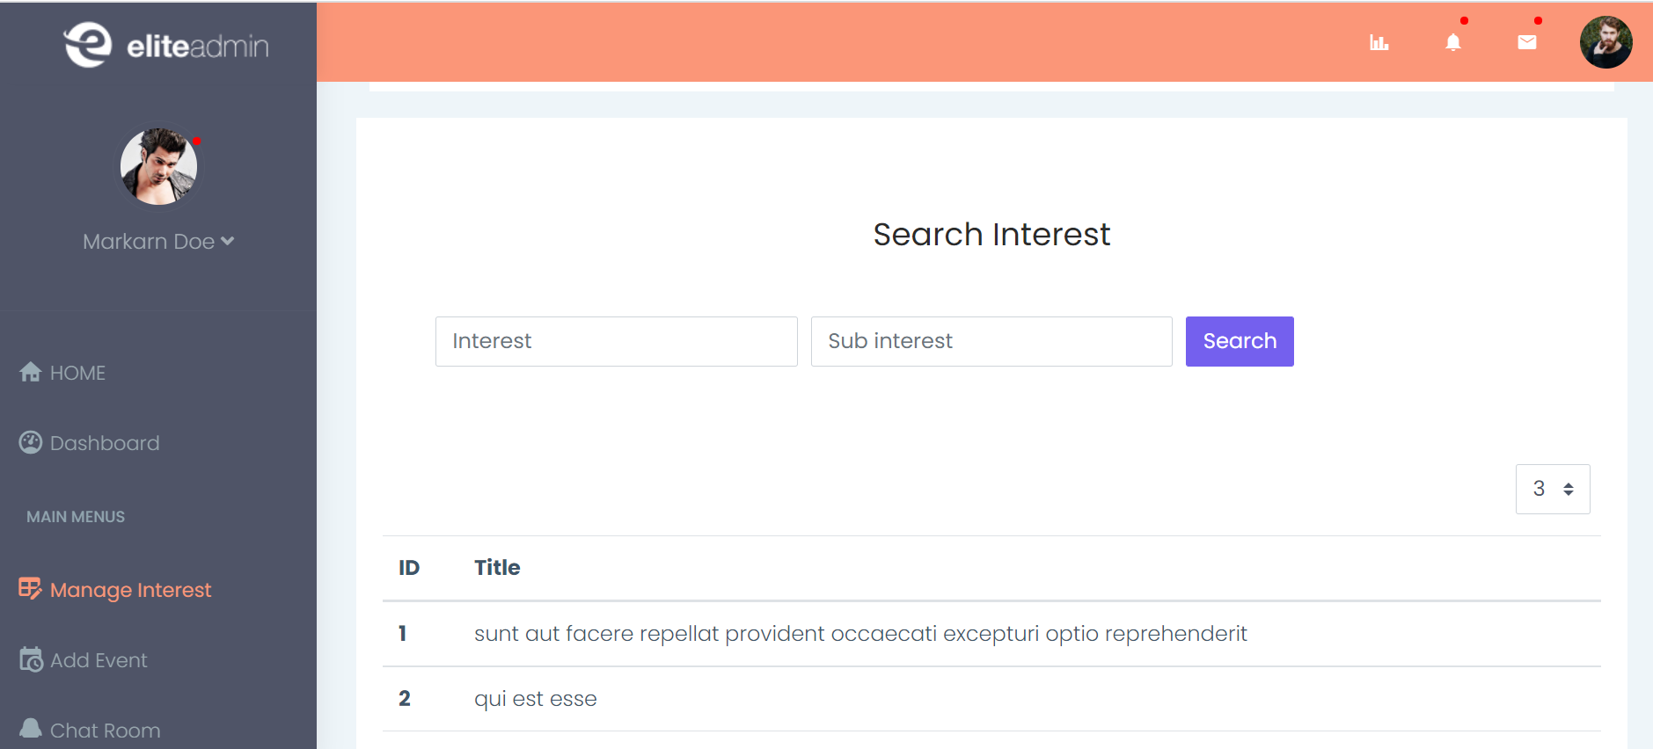

1. Add Event

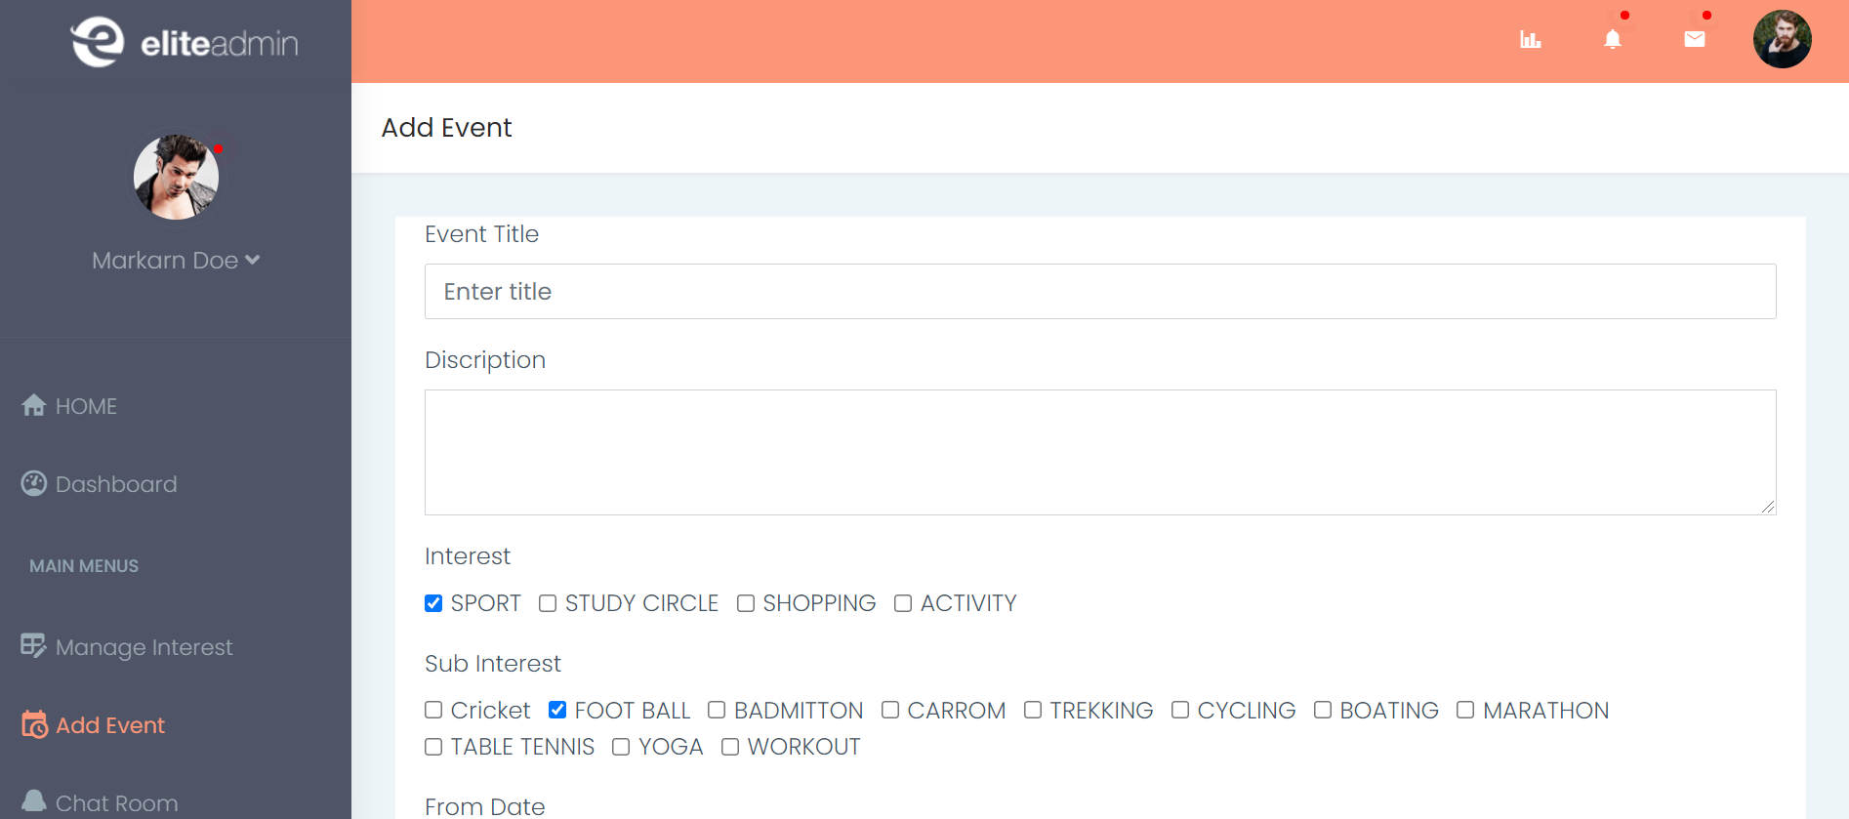

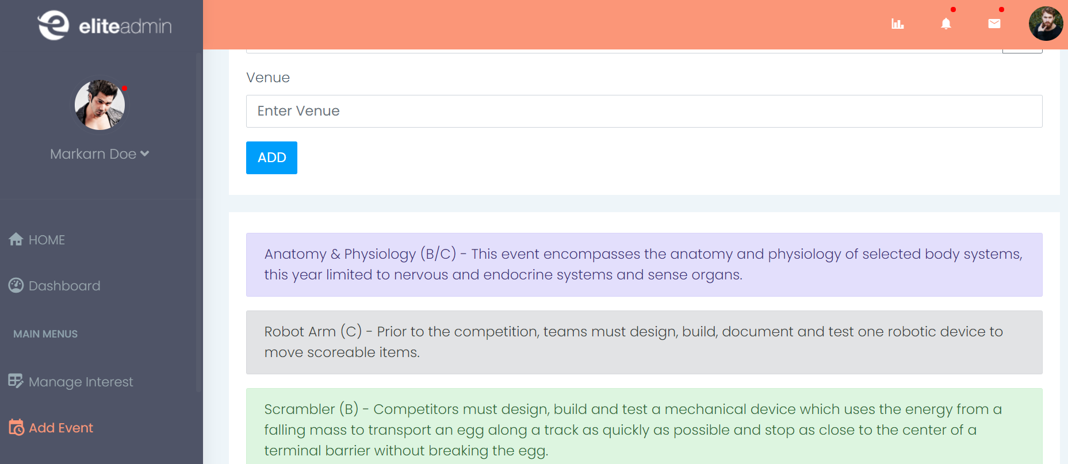

1. Chat Room

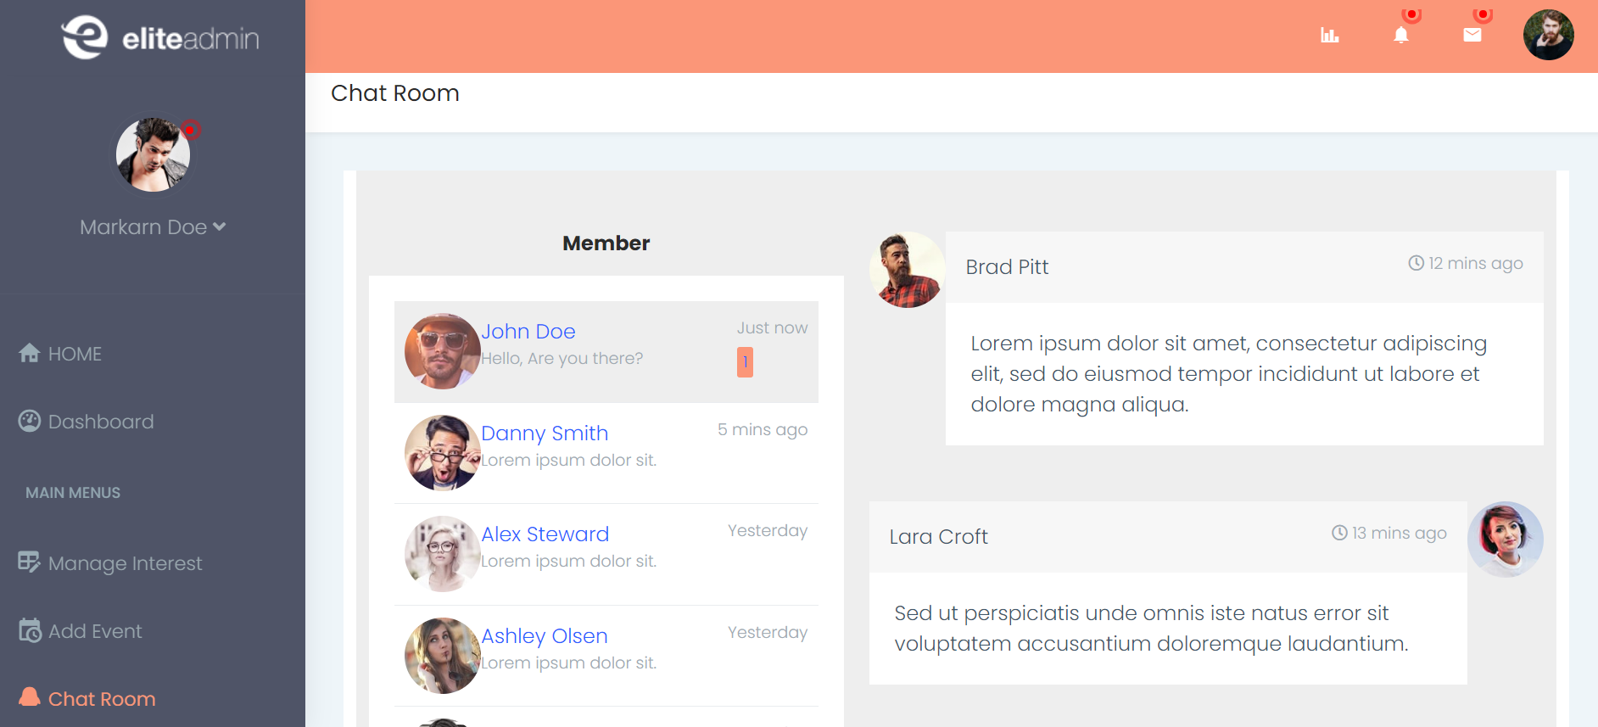

10) Main Interest chart

